UKNOSIG Website & Social Media

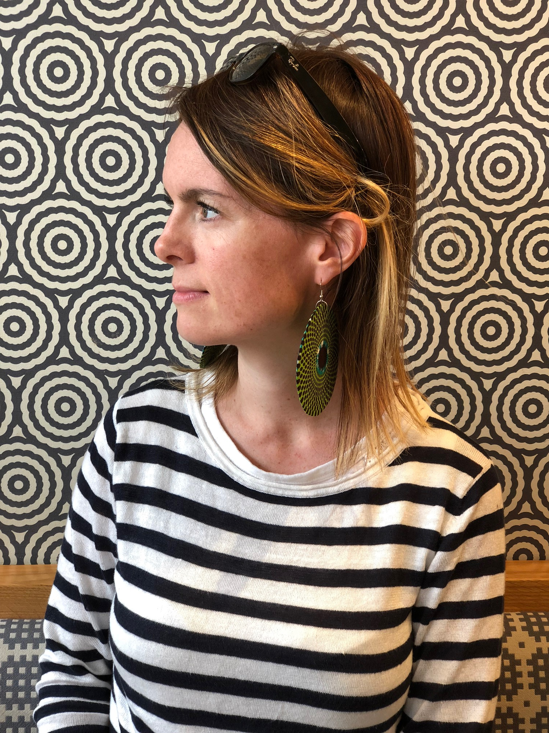

Ailbhe Burke is a Neurologist, and the current post-CCT Neuro-Ophthalmology Fellow at Moorfields Eye Hospital in London. She is also an honorary fellow at the National Hospital for Neurology & Neurosurgery, Queen Square

Ailbhe (pronounced Alva) studied psychology & worked in psychiatric genetics at King’s College London before studying medicine at Cambridge, then going on to complete Neurology training in London. Her subspecialist interests are neuro-ophthalmology, particularly eye movements, neurogenetics and neurodegeneration. She has general interests in improving access to and equity within healthcare, as well as exercise and extreme environments.

